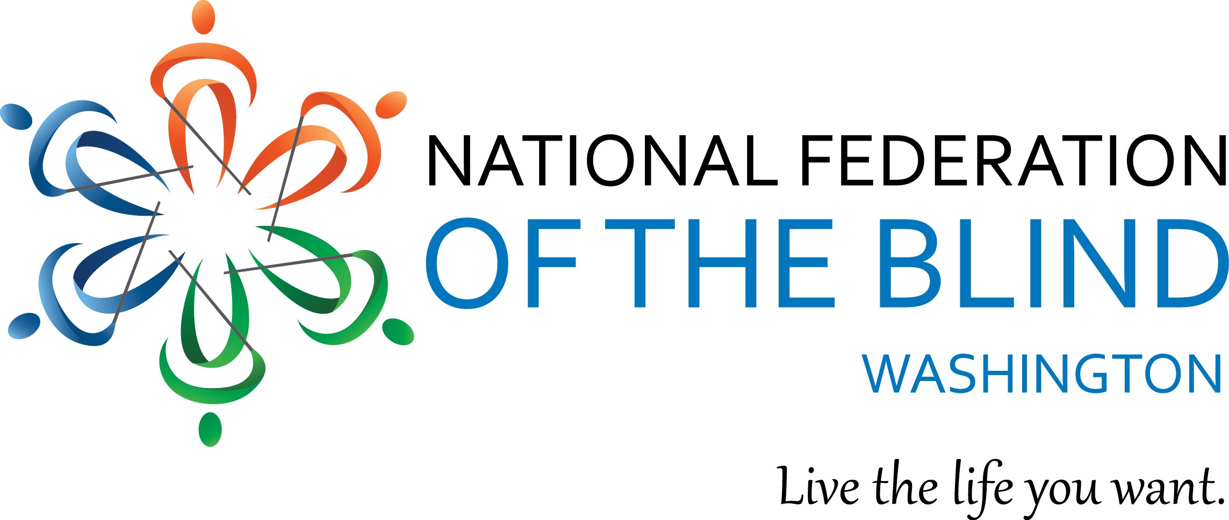
Instructions for Scholarship Application

The National Federation of the Blind of Washington is pleased to announce that we are accepting applications for our 2024 state Scholarship Program. We will award 3 $3000 scholarships to 3 outstanding blind scholars in our state. The scholarships will be awarded at the banquet of our National Federation of the Blind of Washington annual convention, which will be held at the Heathman Lodge in Vancouver, WA from February 29to March 3rd 2024.

In addition to a scholarship, each winner will receive directions and financial assistance to attend the NFB of Washington annual convention, providing an excellent opportunity for networking with active blind persons in many different professions and occupations. The scholarships are awarded at the banquet on Saturday night of the convention. It is required that Scholarship Winners attend the entire convention weekend.

Official Rules

All applicants must be:

- Legally blind in both eyes
- Residents of the state of Washington
- Pursuing a full-time undergraduate or graduate course of study. If employed, part-time study will be accepted.
- Available to participate in the entire NFB of Washington state convention
- 18 years of age by the first day of convention (February 29th)

Each scholarship packet must include:
- Completed scholarship application form
- An essay describing the applicant’s abilities, academic achievements, community leadership, future goals and philosophy of blindness. Please let your personality shine. We want to get to know you.
- High school and/or up-to-date college transcripts
- 3 letters of recommendation

IMPORTANT SIDE NOTE:
All documents submitted MUST BE IN AN accessible format. It is recommended that you test the documents you intend to submit for consideration. Acceptable formats include: Microsoft Word documents, Plain text documents and PDF files. If you plan to submit a document in a format not mentioned here, you will need to ensure the accessibility for use with screen reading software. If you are not sure, please feel free to contact one of the Scholarship Committee Co-Chairs. Contact information will be listed below.

Submission Procedure/Guidelines
- All applicants must contact one of the scholarship committee co-chairpersons for a telephone interview. Please contact Nikki Palm at 360-703-8641 or Bennett Prows at 425-814-4187.

- All completed scholarship packets must be received by Friday, February 2, 2024. APPLICATION PACKETS RECEIVED AFTER this date WILL NOT BE CONSIDERED. Additionally, INCOMPLETE or INACCESSIBLE PACKETS WILL BE DISQUALIFIED.

Send completed scholarship application packets to:
Nikki Palm & Bennett Prows
NFB of Washington Scholarship co-chairpersons
- Nikki Palm: nikkirae83@gmail.com
- Bennett Prows: BJProws@comcast.net.

If you have any additional questions, please contact Nikki Palm or Bennett Prows at the telephone numbers listed above.

NFBW Scholarship Application Form

Please feel free to make additional copies of this letter and application form and distribute them to any interested blind students.

Name (First, Last): ____________________________________________

Date of Birth: ___

Home Address (Please include Street Number, City, State & Zip): ___________________________________

Home Phone: _____________

Cell Phone: _____________

Email: _________________________

Your Current Grade Point Average:
Your Current class standing: ___________________

High School Attended: __________________________________________

Address (Please include Street Number, City, State & Zip): ____________________________________________________________________

Dates Attended: _____________________

College/Institution to be attended in the next enrollment period: _______________________________________

Address (Please include Street Number, City, State & Zip): _______________________________________________________

Phone (Please include area code): ______________________

Major: ____________________________________________________

Career Goal: ________________________________________________________

Please briefly describe your future career in more detail. In addition, why is this the career path you have chosen?
_____________________

